APQB 4.3 Measurement and Functions of Money

- On the island of Mabera, the local money is called “favoli.” The price of every good in Mabera is expressed as the number of favolis needed to buy the good. The use of favolis to express the price of goods describes which function of money?
- Store of value
- Medium of exchange
- Means of payment
- Unit of account
- Store of wealth
- The table below gives the value of various monetary measures, in millions of dollars.
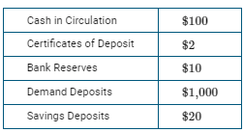
Based on the table above, what is the value of M1, a measure of the money supply?
- $100 million
- $102million
- $112million
- $1,000million
- $1,120million
- Fred Jones withdraws $1,000 in cash from his savings account. What immediate effect does this transaction have on the monetary aggregate measures of M1 and M2 ?
- M1 will increase; M2 will decrease
- M1 will increase; M2 will not change
- M1 will decrease; M2 will not change
- M1 will not change; M2 will decrease
- M1 will not change; M2 will not change
- Assume that in a banking system in which banks hold no excess reserves, the public holds part of its money in cash and the rest in checking accounts. If the required reserve ratio is 10 percent, actual reserves are $10 million, and currency in circulation is equal to $20 million, M1 will be equal to
- $20 million
- $30 million
- $90 million
- $120 million
- $150 million
- The narrowest definition of money, M1, includes which of the following
- savings accounts
- bank reserves
- government bonds
- certificates of deposit
- credit cards
- Which of the following is counted in the M2 measure, but not the M1 measure, of the United States money supply?
- Savings accounts
- Currency
- Stocks
- Small time deposits
- Checkable deposits
- A barter economy is different from a money economy in that a barter economy
- encourages specialization and division of labor
- involves higher costs for each transaction
- eliminates the need for a double coincidence of wants
- has only a few assets that serve as a medium of exchange
- promotes market exchanges
- The table below gives the value of various monetary measures, in millions of dollars.
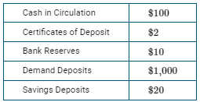
Based on the table above, what is the value of the monetary base?
- $100 million
- $102 million
- $110 million
- $112 million
- $1,112 million
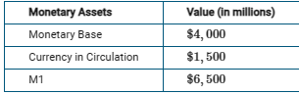
- Based on the data provided, what is the value of total reserves held by depository institutions?
- $500 million
- $1,500 million
- $2,500 million
- $5,500 million
- $8,000 million
- Assume that in a banking system in which banks hold no excess reserves, the public holds part of its money in cash and the rest in checking accounts. If the required reserve ratio is 10 percent, actual reserves are $10 million, and currency in circulation is equal to $20 million, M1 will be equal to
- $20 million
- $30 million
- $90 million
- $120 million
- $150 million
- Fred Jones withdraws $1,000 in cash from his savings account. What immediate effect does this transaction have on the monetary aggregate measures of M1 and M2 ?
- M1 will increase; M2 will decrease
- M1 will increase; M2 will not change
- M1 will decrease; M2 will not change
- M1 will not change; M2 will decrease
- M1 will not change; M2 will not change
- All of the following are components of the money supply in the United States EXCEPT
- paper money
- gold bullion
- checkable deposits
- coins
- demand deposits

1 | D | 6 | D
2 | E | 7 | B
3 | E | 8 | C
4 | D | 9 | A
5 | C | 10

